Design Updates
URL:
http://us15.campaign-archive1.com/?u=12a794b2402eb103cba5c25f4&id=8750b60b05
- Post my Flight Button - Button needs to be moved further left (see red line)
Currently:
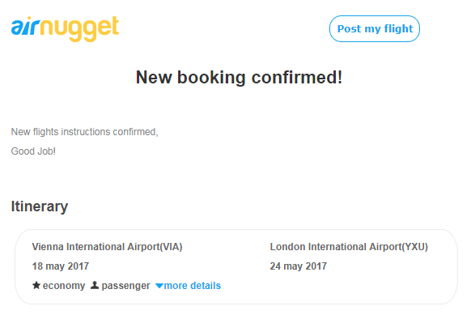
- Please remove text crossed out in red
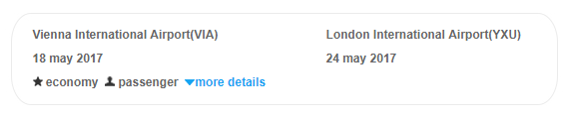

- Move copy further left (red line)
Current
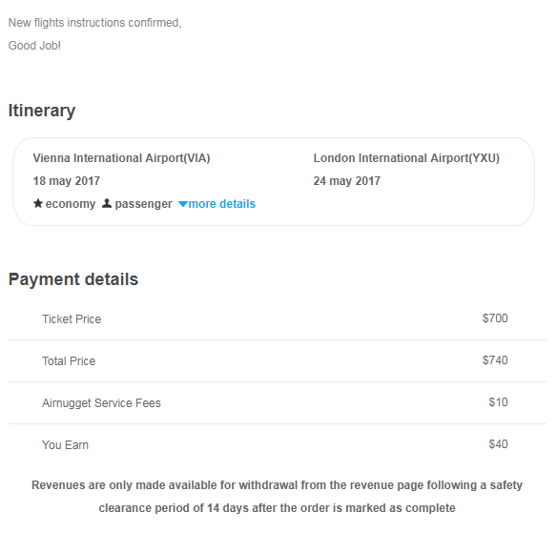

Update
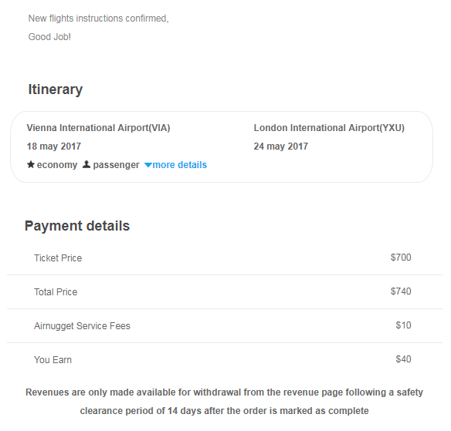
- Please Update Icons and copy space same as provided design
Current:
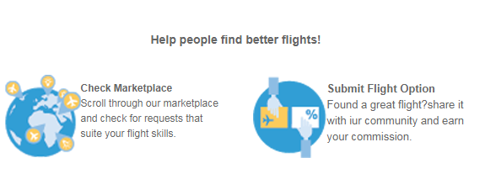

Update:
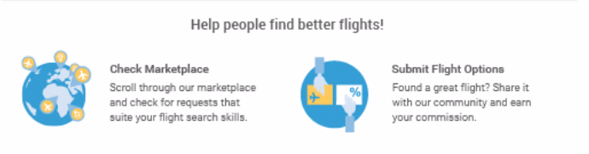

- Button Link URL – Please update as below

https://plus.google.com/116469662694192725459/about

- Logo Link – Add link to Logo

https://airnugget.com/

